**US Media Group Santé Awards Gold and Silver Medals to Croatian Wines**

*Source:* Croatian Premium Wine Imports, Inc. - Santé Awards, Gold and Silver Medals 2024 to Croatian Wines

[Santé Media Group](https://santemagazine.com/), the US-based owner of brands including Santé Magazine, Newsletter, Podcast and Competitions, with over 200,000 food and beverage professional subscribers, has been impressed with the Croatian wines. Here is the just-published article “Croatian Wines Excel at the 2024 Santé Wine & Spirits International Competition” with tasting notes for the Gold and Silver awarded wines from Istrian, Dalmatian and Slavonian wineries.

Awarded wines included Fakin Wines Malvazija with the Gold, and the following with Silver Awards: Kutjevo Premium Rosé, Delmati Winery Biokovo Trbljan, Iločki Podrumi Graševina, Matuško Plavac Mali, Delmati Winery Biokovo Plavka, and Testament Winery Dalmatian Dog Babić. Congratulations, and živjeli!

These and more than 101 indigenous Croatian wine labels can be tasted in the US via [Croatian Premium Wine Imports, Inc.](http://www.croatianpremiumwine.com/) for distribution, or to be shipped to your home in most US states, or via [Croatia Unpacked](https://www.croatiaunpacked.com/) in Canada.

Quoting Santé: “Croatian wines have undergone a remarkable transformation over the past few decades, evolving from local secrets to gaining international recognition. Historically, Croatia’s winemaking roots stretch back over 2,500 years, yet it wasn’t until the early 21st century that the country began to reclaim its reputation for producing high-quality wines.

The improvement in Croatian wines can be attributed to several factors. Winemakers have embraced modern viticultural techniques and invested in state-of-the-art technology, all while respecting traditional methods and the unique characteristics of their indigenous grape varieties, such as Plavac Mali, Malvazija, and Graševina. This blend of tradition and innovation has resulted in wines that are not only diverse and unique but also harmonious and well-crafted.

Croatia’s diverse terroirs—ranging from the coastal influences of Istria and Dalmatia to the continental climate of Slavonia—allow for a wide variety of wine styles, from crisp whites and robust reds to aromatic rosés and dessert wines. The emphasis on quality over quantity has been a key factor in the enhancement of Croatian wines, with many wineries focusing on sustainable practices and limited production to ensure excellence.

As a result, Croatian wines have steadily gained a foothold on the international stage, earning accolades and admiration from critics and wine enthusiasts alike. This renaissance has positioned Croatia as an exciting and burgeoning wine destination, offering distinctive and memorable experiences for those looking to explore beyond the traditional wine regions.

These wines won significant awards in the 2024 Santé Wine & Spirits International Competition.

**Gold**

**Fakin Malvazija, 2022**

Fakin Malvazija 2022 from Croatia is a vibrant and refreshing white wine that captures the essence of the Istrian region. With its straw-yellow color and aromatic bouquet of citrus and floral notes, it offers an inviting experience right from the first pour. On the palate, you’ll find zesty flavors of lemon, lime, and green apple, complemented by a touch of minerality and a hint of Mediterranean herbs. The crisp acidity and medium-bodied texture make it an excellent companion for seafood, light pastas, or as a standalone sipper. This vintage is a delightful exploration of Croatian winemaking, showcasing the unique qualities of the Malvazija grape.

*Source:* Croatian Premium Wine Imports, Inc. -- Marko Fakin, winemaker at Fakin Wines, and son inspect their vineyards in Motovun

**Silver**

**Babić The Dalmatian Dog**, **Testament Winer**y

Babić The Dalmatian Dog wine from Croatia is an engaging red that captures the spirit of the Dalmatian coast. Made from the native Babić grape, this wine displays a deep ruby color and a rich bouquet of dark berries, plums, and hints of Mediterranean herbs. On the palate, it offers a full-bodied experience with flavors of ripe black cherries, dried figs, and a touch of spice, balanced by a robust structure and well-integrated tannins. Its earthy undertones and a dash of minerality add complexity to the wine, leading to a long and satisfying finish. Perfect for pairing with grilled meats or aged cheeses, Babić The Dalmatian Dog is a testament to the depth and potential of Croatian reds.

**BioKovo Red Wine Plavka, 2021**, **Delmati Winery**

BioKovo Red Wine Plavka 2021 is a striking Croatian wine that highlights the unique qualities of the Plavka grape. This organic wine has a vibrant ruby hue and opens with inviting aromas of red berries, cherries, and subtle earthy notes. On the palate, it is medium-bodied, featuring flavors of ripe strawberries and red currants, complemented by a touch of spice and a hint of herbal undertones. Its balanced acidity and soft tannins provide a smooth texture, making it an approachable yet intriguing red. With its commitment to organic practices and characteristic freshness, BioKovo Plavka 2021 pairs wonderfully with Mediterranean cuisine, grilled vegetables, or roasted poultry, offering a delightful and sustainable wine experience from Croatia.

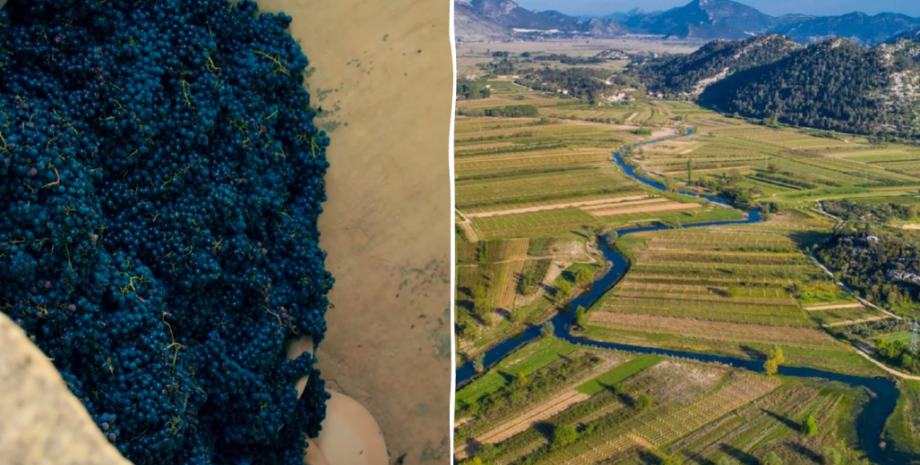

*Source:* Croatian Premium Wine Imports, Inc. – Delmati Plavka and vineyards in the Jezero fields near Vrgorac, Dalmatia

**BioKovo Trbljan White Wine**, **Delmati Winery**

BioKovo Trbljan White Wine from Croatia is a refreshing expression of the Trbljan grape, crafted with a focus on organic viticulture. This wine presents a pale straw color with a bright, inviting clarity. The nose is greeted with crisp aromas of green apple, citrus, and a hint of floral notes, evoking a sense of freshness right from the start. On the palate, it offers a light to medium body with flavors of lemon zest, pear, and a touch of minerality, accompanied by a vibrant acidity that keeps it lively and crisp. The clean finish leaves a subtle impression of almonds and a whisper of herbs, making it an excellent match for seafood, salads, or light appetizers. BioKovo Trbljan showcases the potential of Croatian white wines, marrying traditional techniques with organic principles for a pure and enjoyable experience.

**Graševina**, **Ilok Cellars**

Graševina, one of Croatia’s most beloved white wines, offers a delightful introduction to the country’s winemaking prowess. Known for its fresh and versatile character, this wine typically exhibits a clear, pale straw color. The nose is greeted with aromas of green apple, pear, and subtle floral notes, creating an inviting bouquet. On the palate, Graševina is crisp and vibrant, featuring flavors of citrus and stone fruits, with hints of white peach and lemon. Its bright acidity and light to medium body make it exceptionally food-friendly, pairing well with seafood, light pastas, and salads. Graševina is a staple in Croatian wine culture, appreciated for its refreshing qualities and approachable, balanced style. Whether enjoyed on a sunny afternoon or as a complement to a meal, this wine captures the essence of Croatian viticulture.

**Kutjevo Rosé**

Kutjevo Rosé from Croatia is a charming and refreshing wine that beautifully captures the essence of its region. With a delicate pink hue, this rosé entices with aromas of fresh strawberries, raspberries, and a hint of citrus zest. On the palate, it is light and invigorating, featuring flavors of red berries balanced by a crisp acidity that provides a clean and lively finish. The wine’s subtle minerality adds an extra layer of interest, making it both refreshing and nuanced. Perfect for sipping, Kutjevo Rosé pairs wonderfully with light appetizers, seafood dishes, or simply enjoyed on its own. This wine is a testament to the finesse and appeal of Croatian rosés, offering a delightful and vibrant tasting experience.

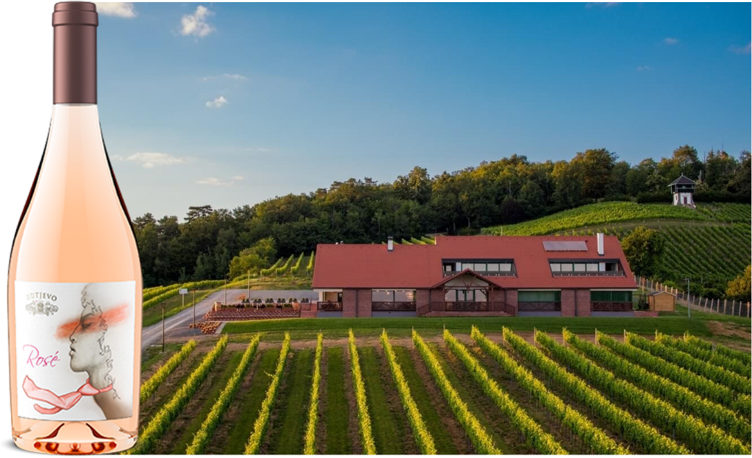

*Source:* Croatian Premium Wine Imports, Inc. – Kutjevo Winery 1232 is the oldest Croatian winery with records dating back to the 13th century, Today this is a modern winery, with its new restaurant Vinkomir built in the vineyards and modern design label including Croatian “kravata.”

**Matuško Plavac Mali 2020**

Matuško Plavac Mali 2020 is a robust and expressive red wine that showcases the depth and complexity of Croatia’s Plavac Mali grape. Originating from the sun-drenched Dalmatian coast, this wine presents a deep garnet color in the glass. The nose is rich with aromas of dark fruits, such as blackberries and plums, intertwined with notes of Mediterranean herbs and a hint of black pepper. On the palate, it is full-bodied, offering bold flavors of ripe black cherries and dried figs, complemented by a touch of earthiness and well-structured tannins, lending hints of vanilla and spice, and enhancing its complexity. The finish is long and satisfying, making it a wonderful companion for grilled meats, aged cheeses, or hearty stews. Matuško Plavac Mali 2020 is a testament to the power and elegance that Croatian red wines can offer, delivering a memorable and flavorful experience.”

###

For information about indigenous Croatian wines, contact [info@CroatianPremiumWine.com](mailto:info@CroatianPremiumWine.com)

<https://santemagazine.com/croatian-wines-excel-at-the-2024-sante-wine-spirits-international-competition/>